**Assignment Brief – BTEC**

|  |  |  |  |  |  |
| --- | --- | --- | --- | --- | --- |
| **Programme** | | Level 3 Extended Diploma in Creative Media Production (Games Development) | | | |
| **Unit number(s) and title covered** | | Unit 67: 3D Animation | | | |
| **Assignment number & title** | | Assignment Two: Planning a 3D Animation | | | |
| **Student name** | | *Lewis Hawkins* | | | |
| **Assessor** | | David Matravers | **Internal Verifier** | *James Shaun* | |
| **Date issued** | | 21.01.2019 | **Submission deadline** | 28.02.2019 *at* ***4.30pm*** | |
| **Assessment Criteria** | **To achieve the criteria, the evidence must show that the student is able to:** | | | | **Assessor confirm met** |
| **P2** | Generate outline ideas for a 3D animation working within appropriate conventions and with some assistance | | | |  |
| **M2** | Generate detailed ideas for a 3D animation showing some imagination and with only occasional assistance | | | |  |
| **D2** | Generate thoroughly thought through ideas for a 3D animation showing creativity and flair and working independently to professional expectations | | | |  |

|  |  |  |  |  |  |  |  |
| --- | --- | --- | --- | --- | --- | --- | --- |
| **Assessor feedback - 1st submission** | | | | | | | |
|  | | | | | | | |
| **Did the learner meet the original deadline or agreed extension?** | | Yes ☐ No ☐ | | | | | |
| **Assessor signature** |  | | | | **Date** | |  |
| **Resubmission authorised?** | | Yes ☐ No ☐ | | | | | |
| **New agreed deadline date for submission** *\* must be within 10 days of receiving original assignment back* | |  | | | | | |
| **Lead Internal Verifier signature** |  | | | **Date** | |  | |
| **Assessor feedback - Resubmission** | | | | | | | |
|  | | | | | | | |
| **Assessor signature** (resubmission only) |  | | **Date** | | | |  |

|  |  |  |  |  |
| --- | --- | --- | --- | --- |
| **Scenario** | | | | |
| Following on from the document you produced for “3D Modellers “R” Us” about the different theories and applications of 3D they are now looking into getting into the 3D animation game.  They are unsure about how to go about planning their animation to start. In this assignment you will need to design and plan a 3D animation in preparation for creation to give them a full understanding about what it entails. | | | | |
| **Tasks and criteria covered** | | | | |
| **Task 1 – P2, M2, D2**  Within this task you have to generate thoroughly though out ideas for a 3D animation showing creativity and flair. Your animation planning can be based on any theme/idea you would like but must adhere to a 16 – 25 year old target audience of all genders.  You will need to ensure you have evidence for all of the following topic areas.   * **Stimulus**: *eg client brief, own brief, from market research* * **Ideas**: *brainstorming; sketches; pre-visualisation (concept drawings, storyboards)* * **Legal and ethical considerations**: *legal, eg copyright; ethical, eg confidentiality, decency; representation, eg race, gender, religion, sexuality* * **Specification**: *target audience; key visual themes; constraints, eg polygon count, image resolution, frame rate, output size and aspect ratio, file type, file size*   You should take the time to ensure you cover all the **bold** headings within this task to show full planning capabilities. Included alongside the bold headings are *italicised* topics you may wish to cover. | | | | |
| **Evidence you must produce for this task** | | | | |
| Fully completed portfolio with all bold headings written about. | | | | |
| **Sources of information** | | | | |
| **Textbooks**  Baylis P, Freedman A, Procter N et al – BTEC Level 3 National Creative Media Production, Student Book  (Pearson, 2010) ISBN 978-1846906725  Baylis P, Freedman A, Procter N et al – BTEC Level 3 National Creative Media Production, Teaching Resource  Pack (Pearson, 2010) ISBN 978-1846907371  Ahearn L – 3D Game Textures: Create Professional Game Art Using Photoshop (Focal Press, 2006)  ISBN 978-0240807683  Birm J – Digital Lighting and Rendering (New Riders, 2006) ISBN 978-0321316318  Brooker D – Essential CG Lighting Techniques with 3Ds Max (Focal Press, 2008) ISBN 978-0240521176  Capizzi T – Inspired 3D Modelling and Texture Mapping (Premier Press, 2002) ISBN 978-1931841504  Gahan A – 3ds Max Modelling for Games: Insider’s Guide to Game Character, Vehicle, and Environment  Modelling (Focal Press, 2008) ISBN 978-0240810614  Summers D – Texturing: Concepts and Techniques (Charles River Media, 2004) ISBN 978-1584503002  **Journals**  3D World  Develop Magazine  Edge Magazine  MCV Magazine  **Websites**  www.3dcafe.com – texture and model resources  www.blinkimage.com – use of environment walk-throughs etc  www.turbosquid.com – textures, models and 3D tutorials | | | | |
| **Student checklist** | | | | **Complete?** |
| Proofread work | | | |  |
| Reference / Bibliography (if applicable) | | | |  |
| All pages attached and numbered – including introduction/conclusion/front sheet | | | |  |
| **Authenticity of Evidence Student declaration** | | | | |
| I certify that the evidence submitted for this assignment is my own.  I have clearly referenced any sources used in the work.  I understand that false declaration of authenticity (i.e. plagiarised work) is a form of academic misconduct and the relevant College procedures will be instigated if I am found to be in contravention of these. | | | | |
| **Student signature** |  | **Date of submission** | 06/03/19 | |
| **Re-authentication of Evidence Student declaration (for resubmission only)** | | | | |
| **Student signature** |  | **Date of resubmission** |  | |

NB. Students – the assignment starts on the first page **after** these front sheets, i.e. Page 1.

* For your convenience, page numbers have been inserted into the footer. **Please keep them**.
* You may choose to add a contents table (ToC) in this section.
* Please **do** **not use text boxes** for the main body of your written answers.
* Please make sure that images/screenshots are correctly formatted, laid out and labelled. A table of Figures (ToF) may also be added if you wish.
* Make sure you use Page (or Section) Breaks whenever a new page is required. (Rather than adding large numbers of Return/Paragraph characters.) Ensure that new Section breaks continue with correct orientation and correct page numbers.
* Ensure that you have referenced your work throughout, using references in text and that you also have a reference list and full bibliography at the end of the work according to the current **Harvard Referencing** conventions. **Failure to do so will make your work more difficult to authenticate.**
* **Stimulus**: eg client brief, own brief, from market research
* **Ideas**: brainstorming; sketches; pre-visualisation (concept drawings, storyboards)
* **Legal and ethical considerations**: legal, eg copyright; ethical, eg confidentiality, decency; representation, eg race, gender, religion, sexuality
* **Specification**: target audience; key visual themes; constraints, eg polygon count, image resolution, frame rate, output size and aspect ratio, file type, file size

**Task One:**

**Stimulus:**

**What have I been asked to do:** For this brief I have been asked to create a short 3D rendered animation between 12 – 15 seconds long. It must be created for a 16 – 25-year-old audience of all genders which means I should look to include action, tension, or both.

The animation will be based in a room full of weapons, with soldiers gearing up. Before they can finish an explosion goes off breaching the wall, which makes the soldiers take cover, one flipping over a table. The smoke clears revealing two Akktane soldiers (Aliens) which open fire. One Akktane soldier is killed but the final one fires a shot at the over-turned, but the animation stops before the bullet hits.

This animation was designed because the audience I described in the first paragraph typically enjoy this content.

**Ideas:**

**Storyboard: Each picture is about 3 seconds.**

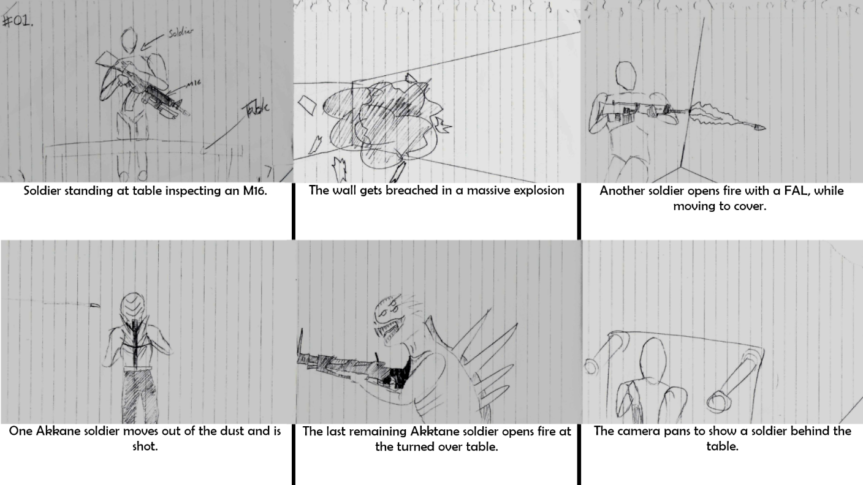

**Mind map:**

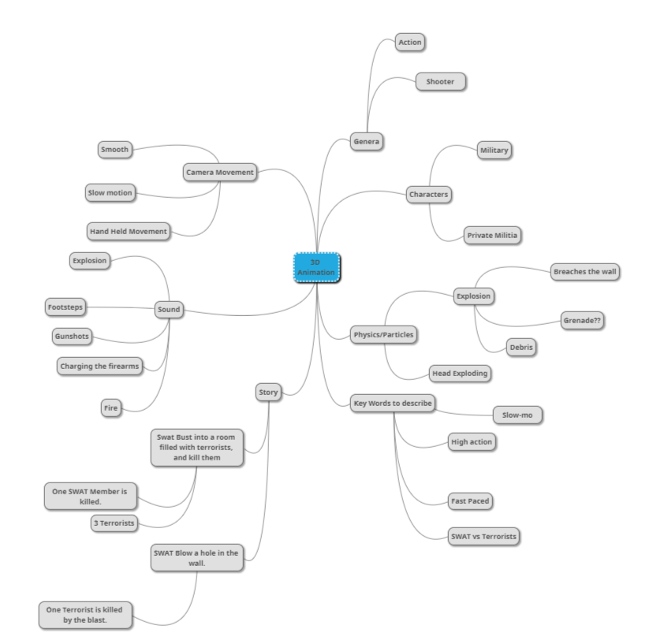

**Concept Sketches for Characters and Weapons:**

Characters:

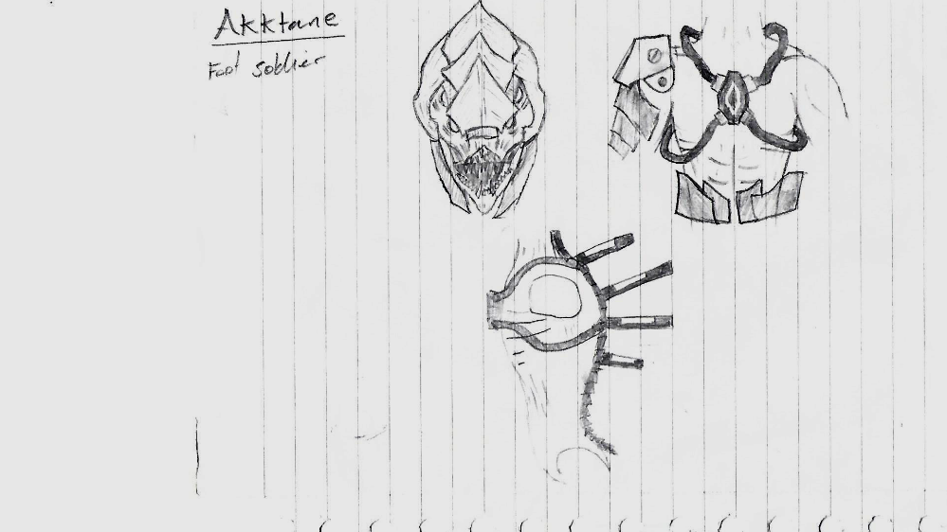

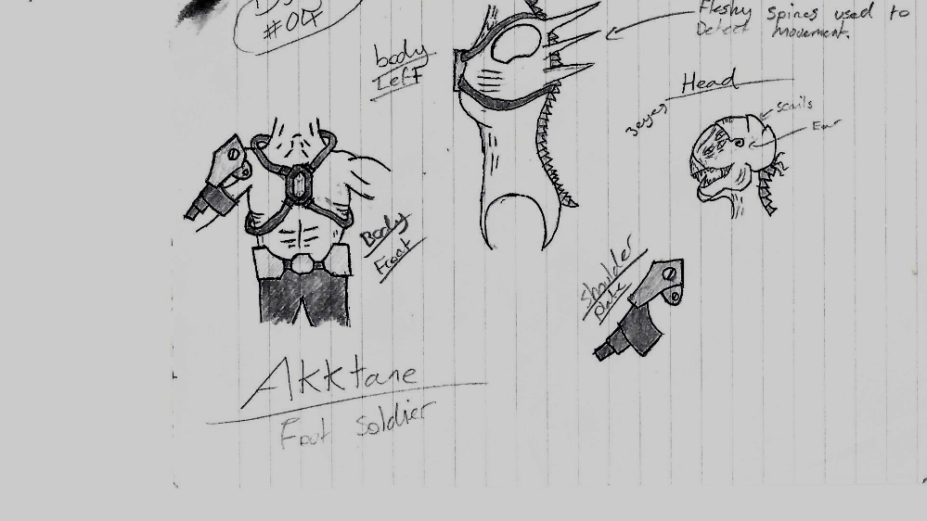

Armour:

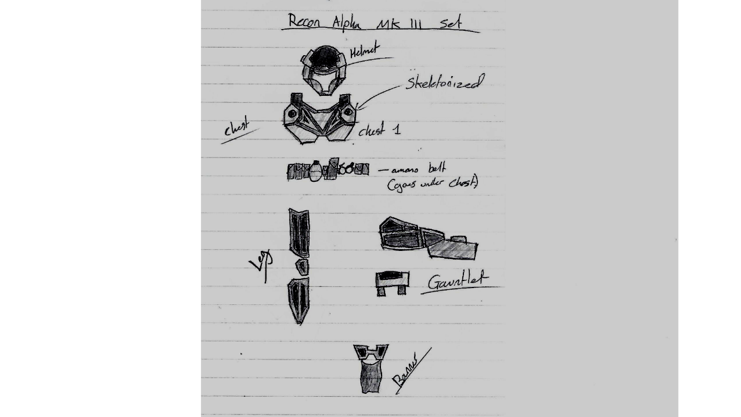

Weapons:

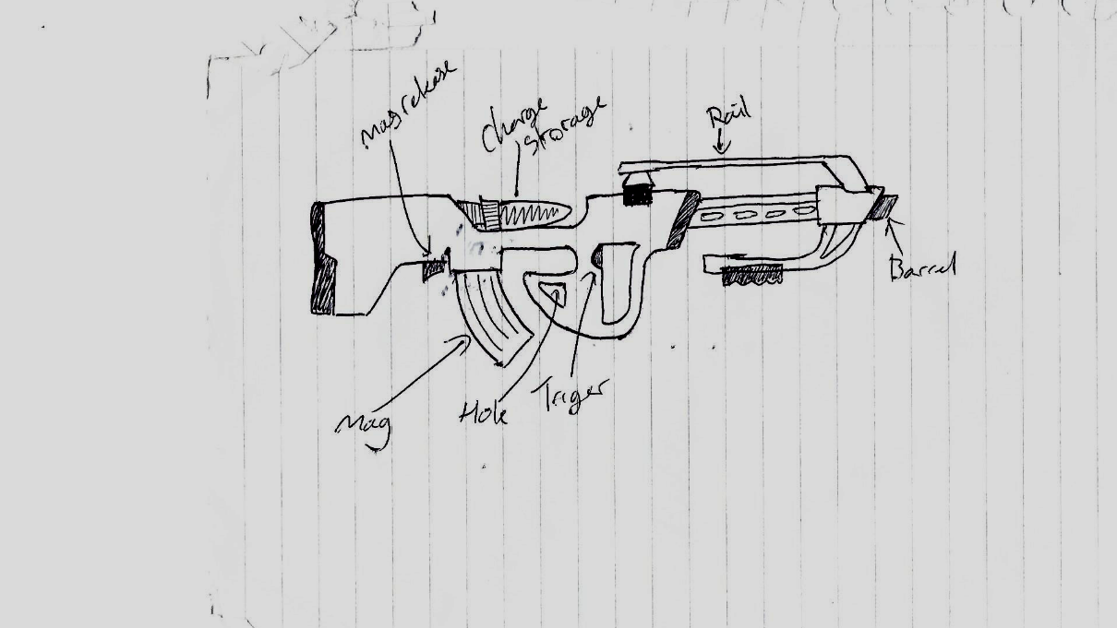

**Legal and Ethical Considerations:**

**Copyright:** Copyright is the right to own work (book, movie, picture, song, video game) given to the original creator. It allows the owner to request a take-down of any illegal use of copyrighted material or pursue damages if they occur.

**Representation of Race, Gender, Sexuality:** When making any media product (short animation in this case) the developer should take into consideration whether the content they produce will have a positive or negative effect on their target audience. Video games like Grand Theft Auto often come under-fire for representing groups of people in an offensive way. This however is countered by the other side with the argument “People that dislike that content are not the target audience”, and “It’s only making fun of the stereotypes, not enforcing them”. These are arguments that should not apply to my animation since its target audience is completely different to Grand Theft Auto, and there is no need for stereotypes.

In my animation I will not be incorporating stereotypes since there’s no need for them. Due to the art style Race, and Sexuality will not be represented in any way, however Gender will be in that all characters are male. This is due to the characters bodies are very generic due to the art-style, which means most people wouldn’t be able to tell the difference between male and female.

**Specification:**

**Target Audience:** Target audience is the group of people that a product is aimed at. A target audience is decided to make it easier to determine content and features for a game. Not using a target audience or using multiple can result in the game being too diverse in content, meaning each group of people will be only interested in some of what the game has to offer. This leaves all players with little to do despite having a good amount of content, which can lead to it loosing players.

**Key Visual Themes:**

**Constraints:**

Resolution: The resolution of the video needs to be low enough to not cause the rendering times to be too high, but at the same time high enough to not look blurry. The required resolution for the brief is 1280 X 720.

Length: The length of the animation needs to be no more than 15 seconds due to the brief setting this requirement. Creating a longer animation would also increase the render times of the total animation.

Polygon Count: High polygon counts causes the rendering times of each frame to increase snice it renders polygon by polygon. The polygon count can be decreased by removing polygons that are not seen by the camera and reducing the polygon density for objects at a distance.

Animation Techniques: The brief requires that multiple animation techniques should be used. The techniques that need to be used are Keyframe, follow a path, physics/simulation (particle systems). I will be implementing walk animations for keyframe, the camera will follow a path, and there will be a particle system for the explosion.